Flying blind photos:

Photo:

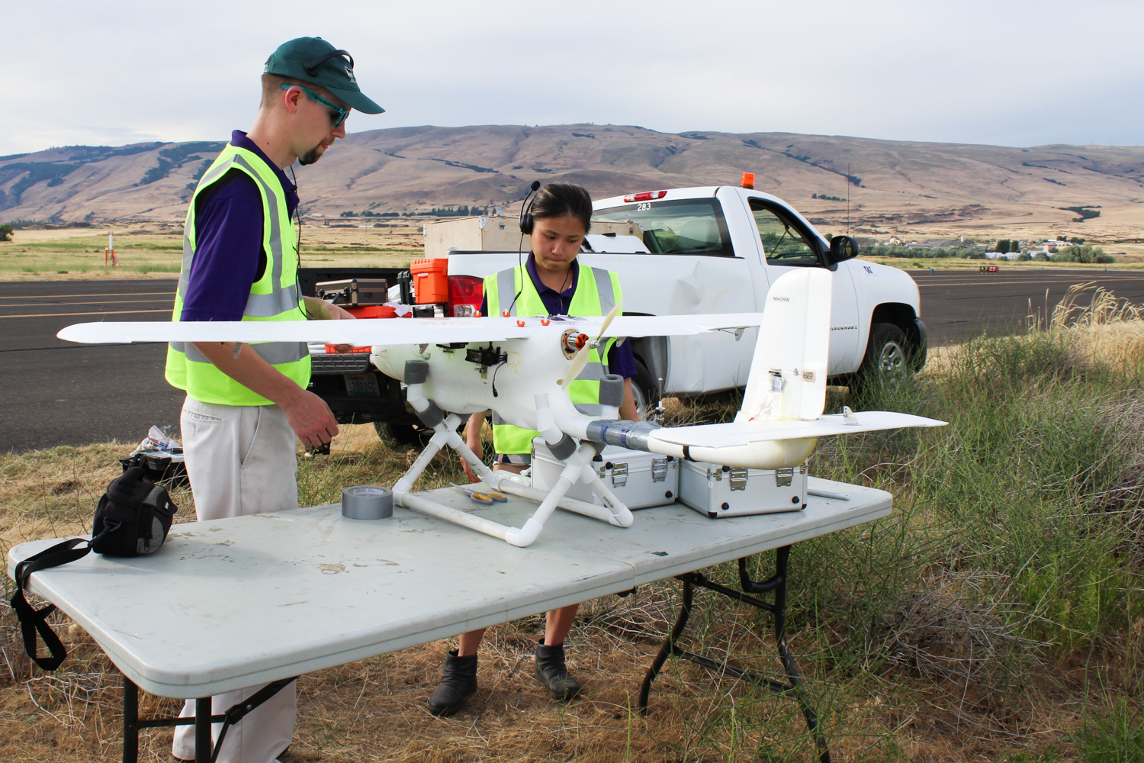

Caption: Recent UW graduates Cory Cantey (left) and Karine Chen prepare the drone, Papaya, for flight.

Credit: XXXXXX/University of Washington

Photo:

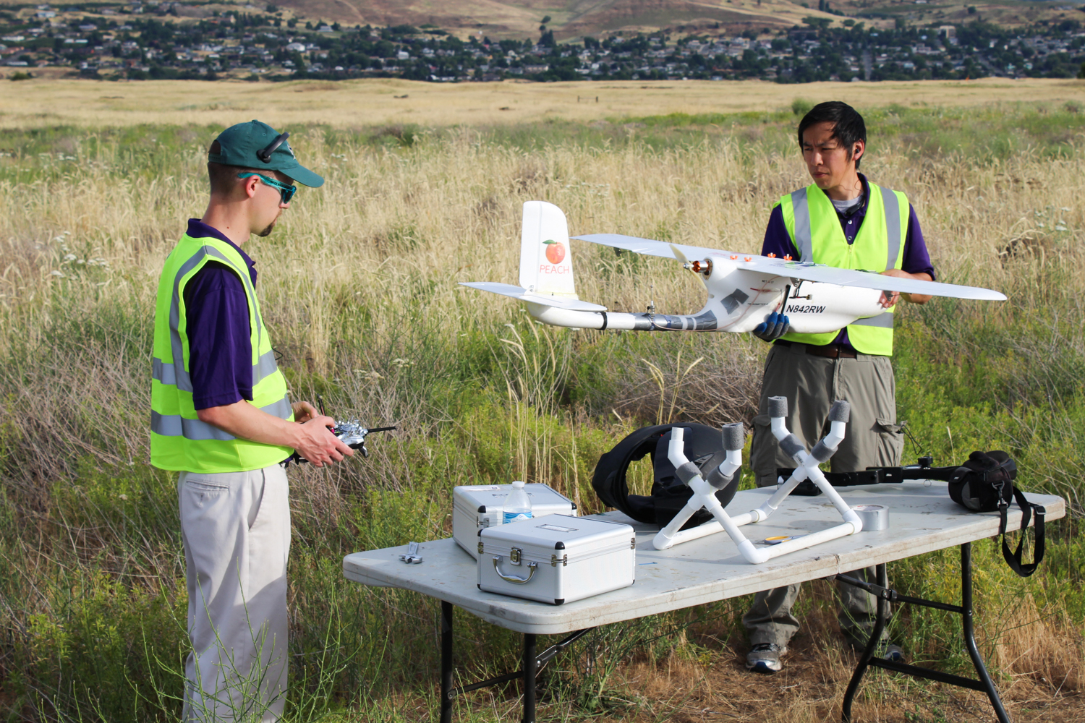

Caption: Recent UW graduate Cory Cantey (left) and Chris Lum perform a pre-flight inspection to make sure the drone, Papaya, is ready to take to the skies.

Credit: XXXXXX/University of Washington

Photo:

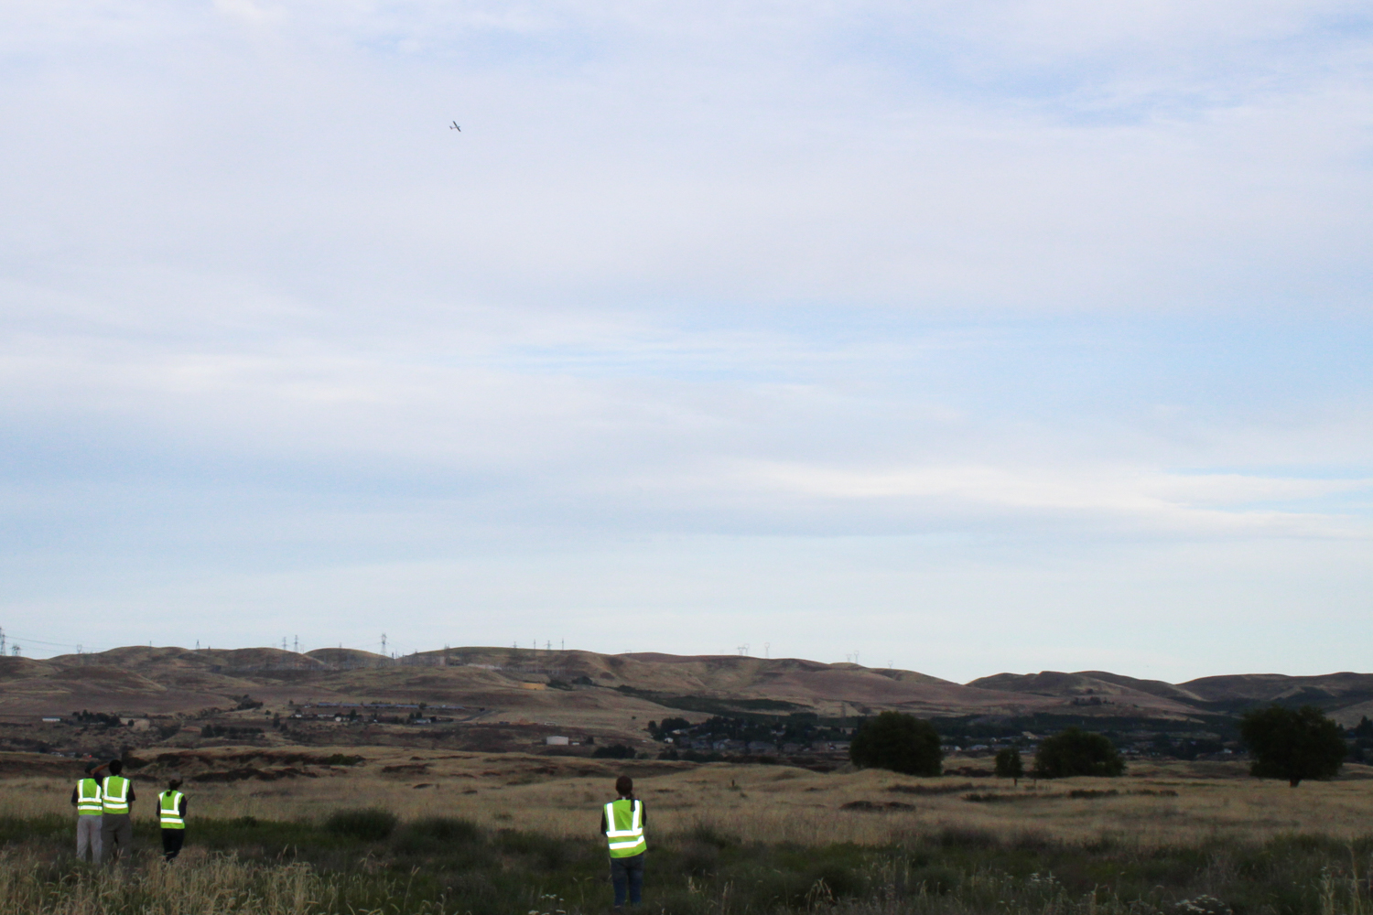

Caption: The aircraft, Papaya, performing the flight test (top left). On the ground (left to right): Cory Cantey (piloting), Christopher Lum, Hannah Rotta and Joshua Brockschmidt.

Credit: XXXXXX/University of Washington

Photo:

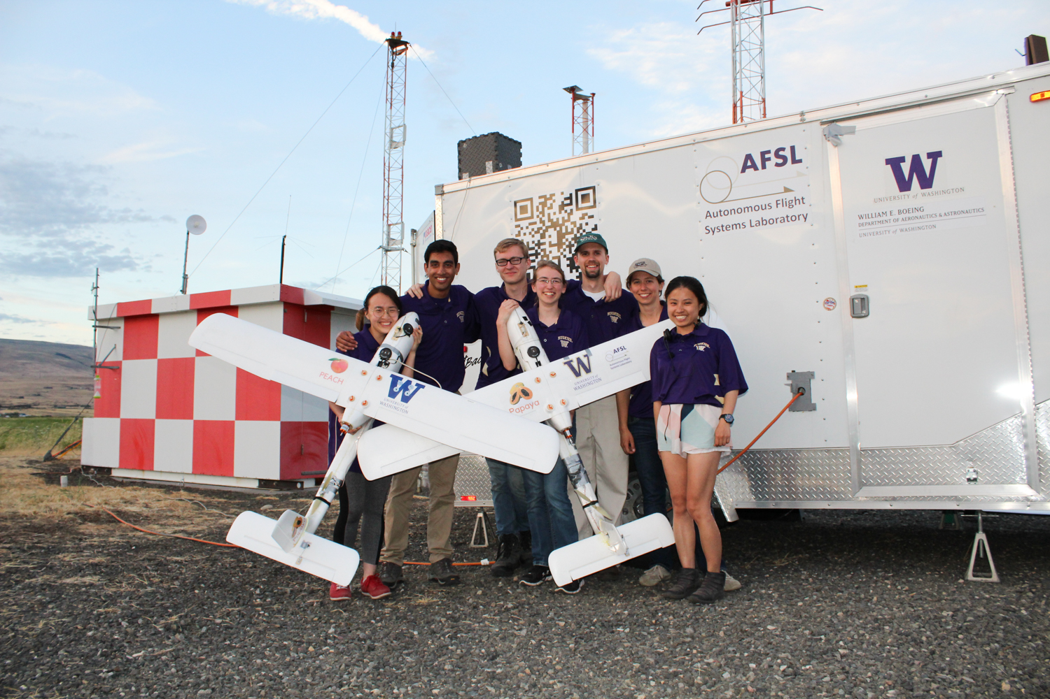

Caption: The team in front of the Autonomous Flight System Laboratory's ground station trailer and the antenna array holding Papaya (right) and the backup aircraft, Peach. From left to right: students Kelly Lee, Ravi Patel, Joshua Brockschmidt, Helen Kuni, Cory Cantey, Hannah Rotta and Karine Chen.

Credit: XXXXXX/University of Washington